**Winter 19**

* Describe regular expression. Explain search () method used in regular expression with suitable example.(4M)
* Explain text rollover with suitable example.(4m)
* Write a Java script that displays textboxes for accepting name & email ID & a submit button. Write Java script code such that when the user clicks on submit button (1)Name Validation (2) Email ID validation (6marks)

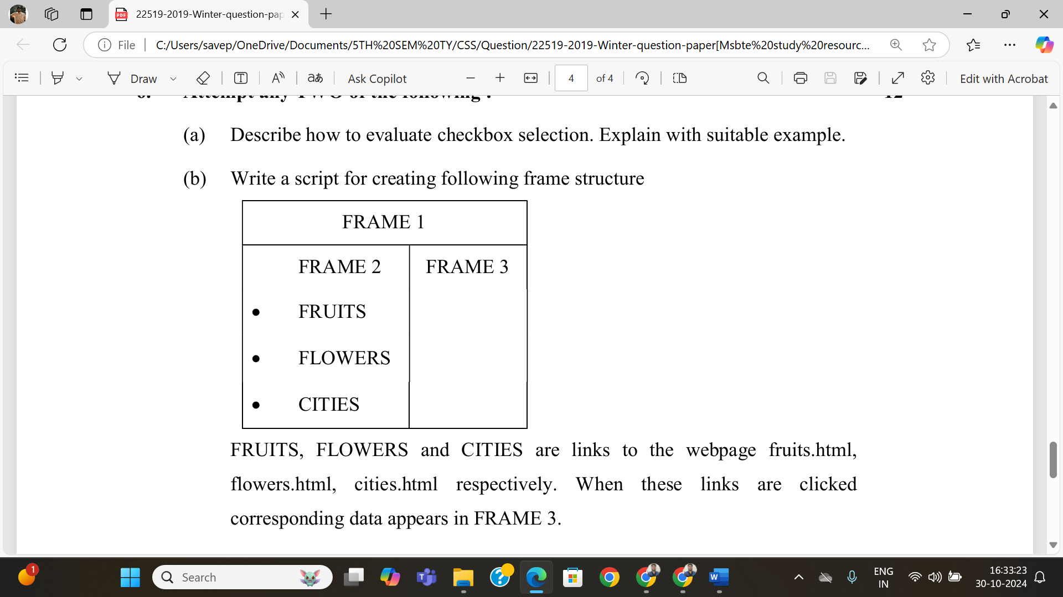(6marks)

**Summer-2022**

1. Explain frame works of javascript and its application.(2marks)
2. Write a javascript program to validate user accounts for multiple set of user ID and password (using swith case statement).(4m)
3. State what is regular expression. Explain its meaning with the help of a suitable example. (4m)
4. Write a javascript program to validate email ID of the user using regular expression.(4m)
5. Write a javascript program to design HTML page with books information in tabular format, use rollovers to display the discount information.(4m)
6. Write a javascript to checks whether a passed string is palindrome or not.(6m)
7. Write a javascript to open a new window and the new window is having two frames. One frame containing buthon as “click here !”, and after clicking this button an image should open in the second frame of that child window.(6m)

**Winter 22**

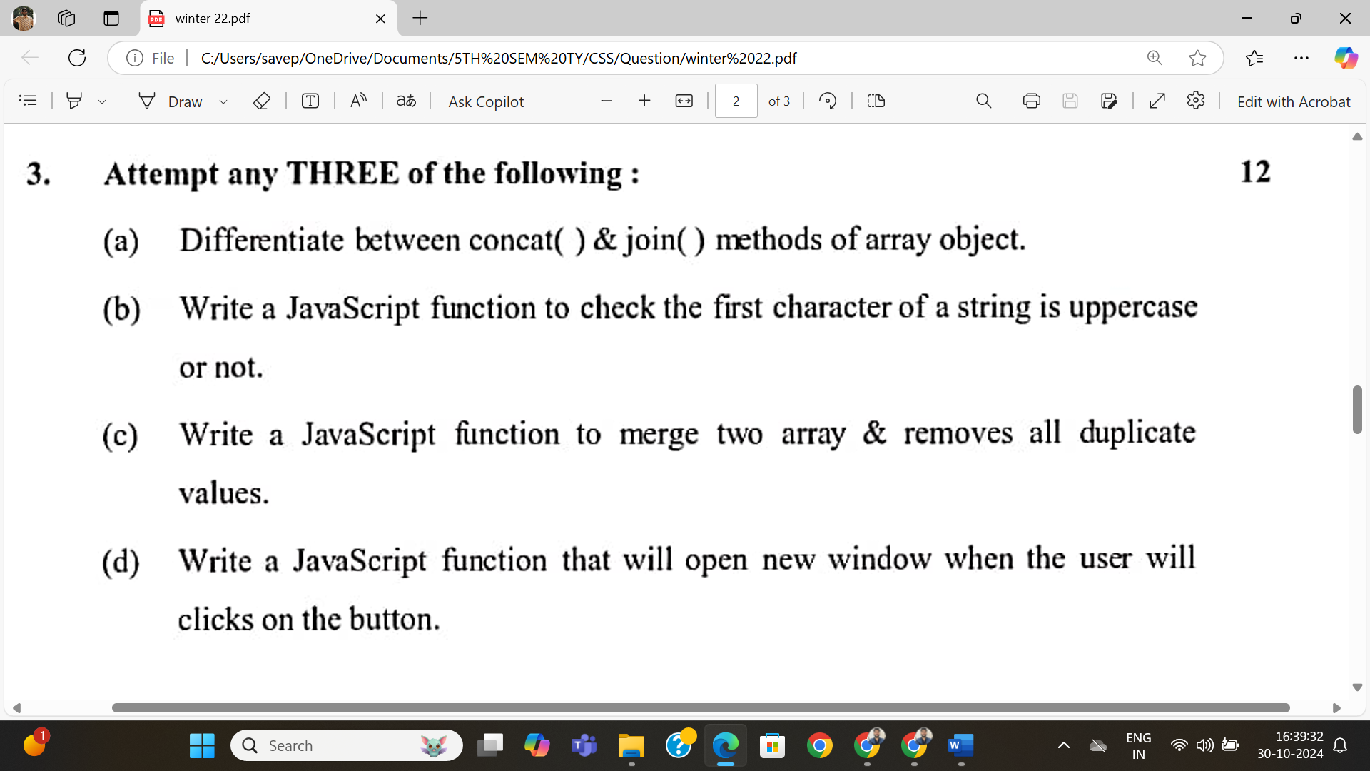

**Describe Quantifier with suitable example (4m)**

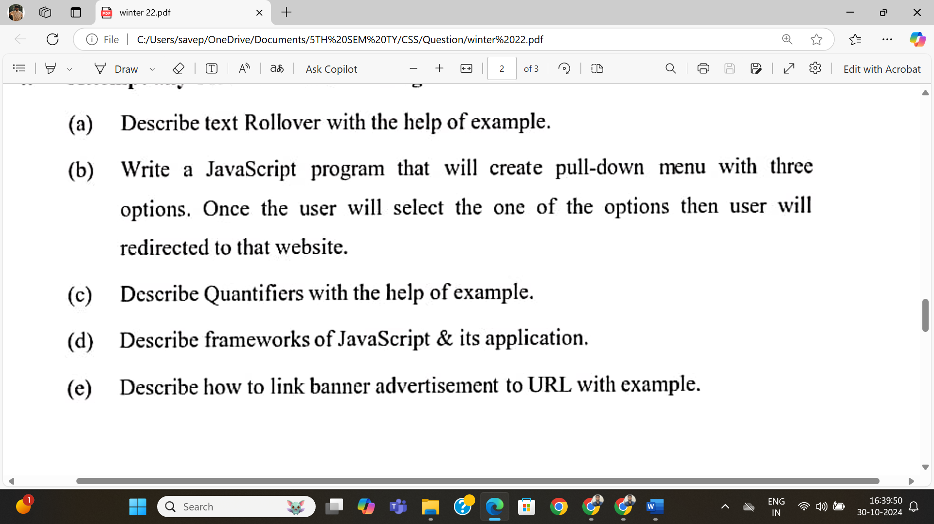

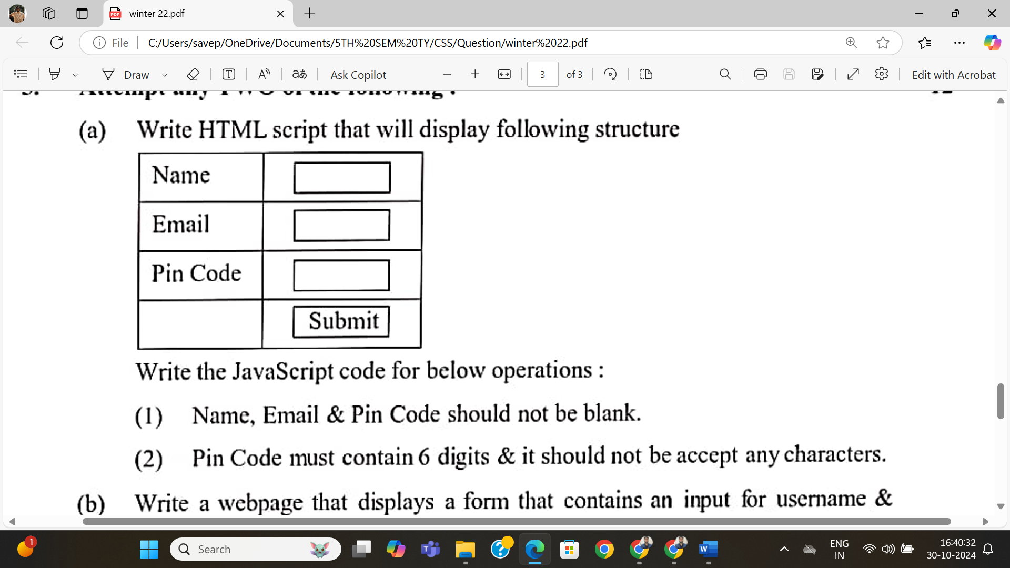

6MARKS

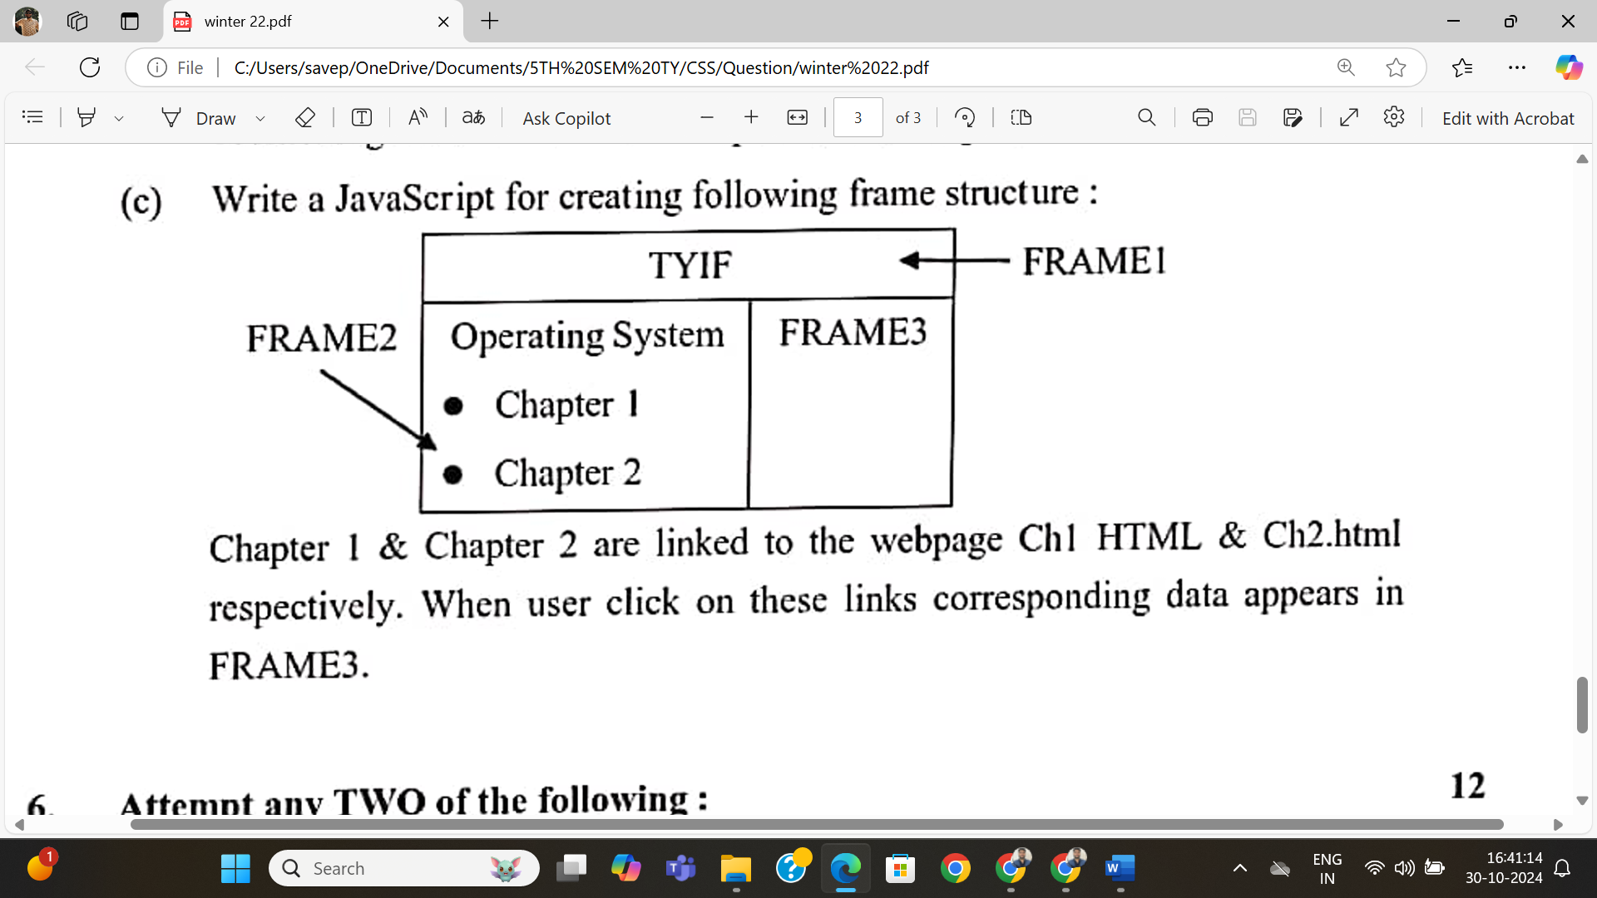

**Summer 2023**

* Explain test() and exec() method of Regular Expression object with example.(4m)
* Explain text and image rollover with suitable example.(4m)
* Write HTML code to design a form that displays textboxes for accepting UserID and Aadhar No. and a SUBMIT button. UserID should contain 10 alphanumeric characters and must start with Capital Letter. Aadhar No. should contain 12 digits in the format nnnn nnnn nnnn. Write JavaScript code to validate the UserID and Aadhar No. when the user clicks on SUBMIT button.(6m)
* 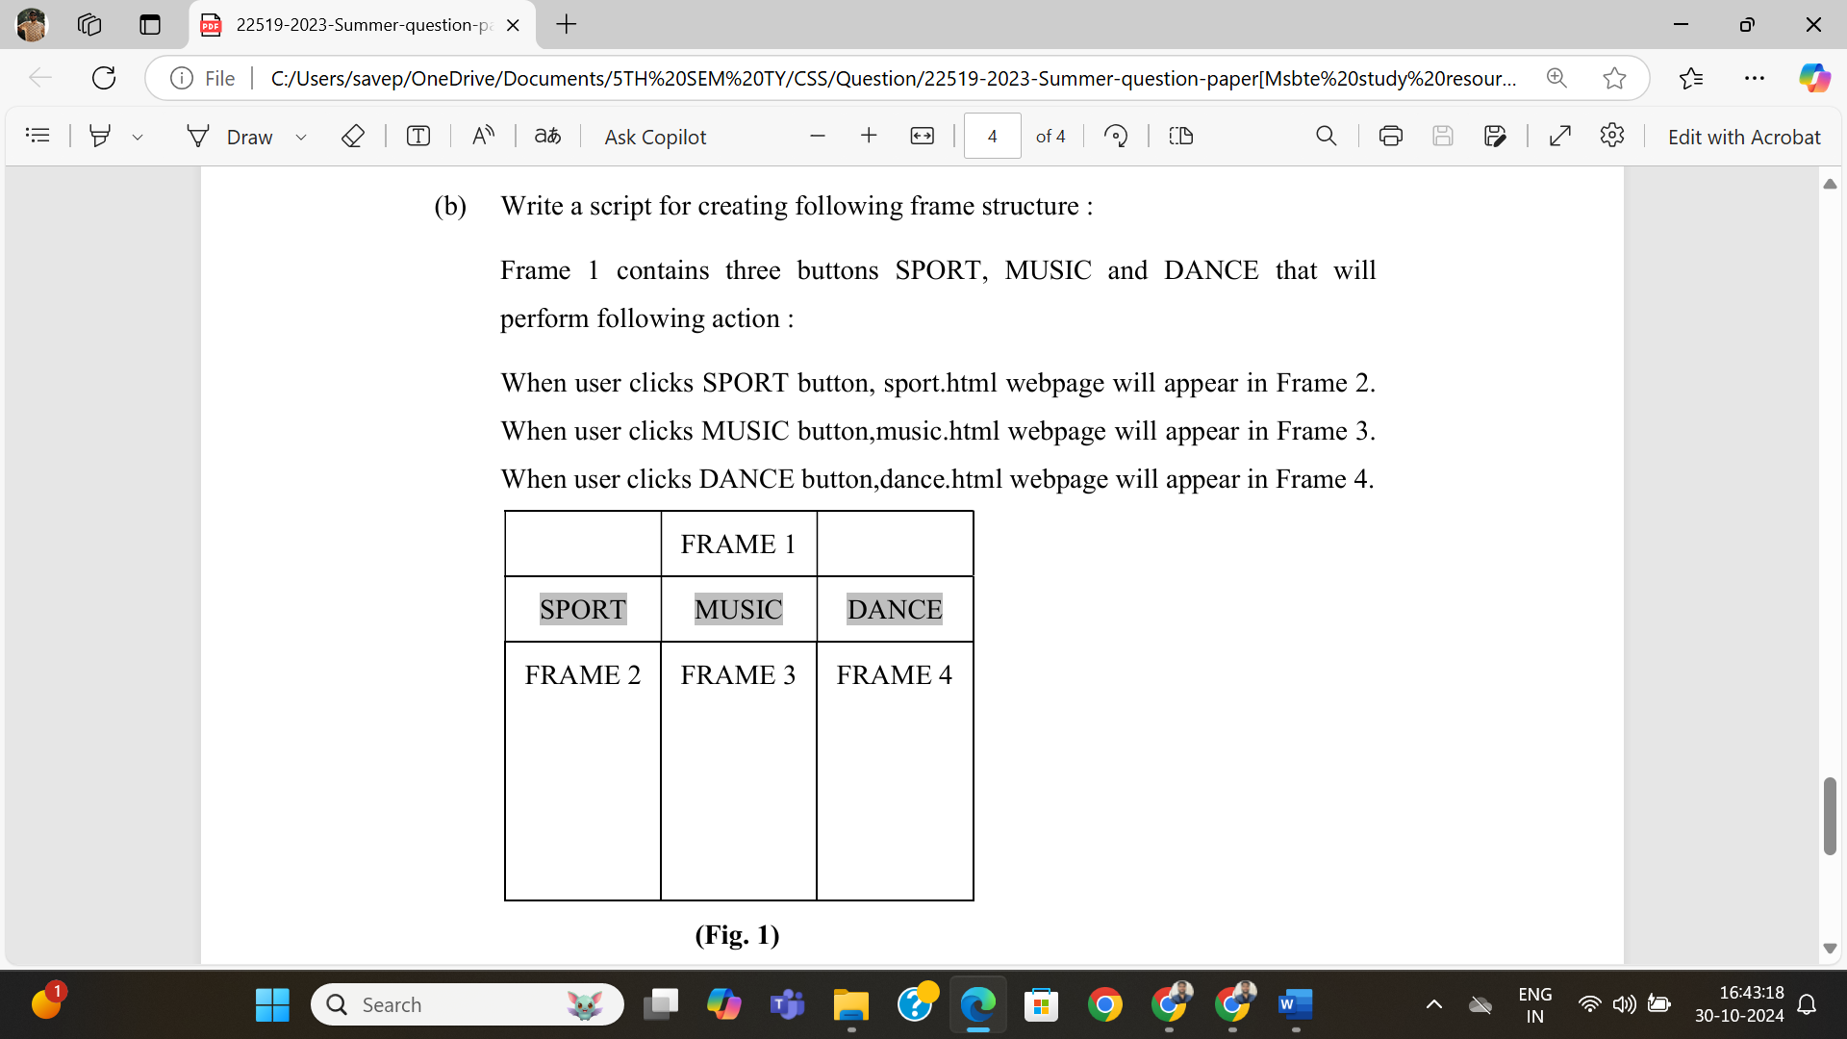 (6m)

**Winter 2023**

* Write a JavaScript that accepts a string and searches for the pattern “MSBTE” in the given string using regular expressions. If the pattern is found, JavaScript will display that “Pattern is found” else display “Pattern is not found”.(4m)



* 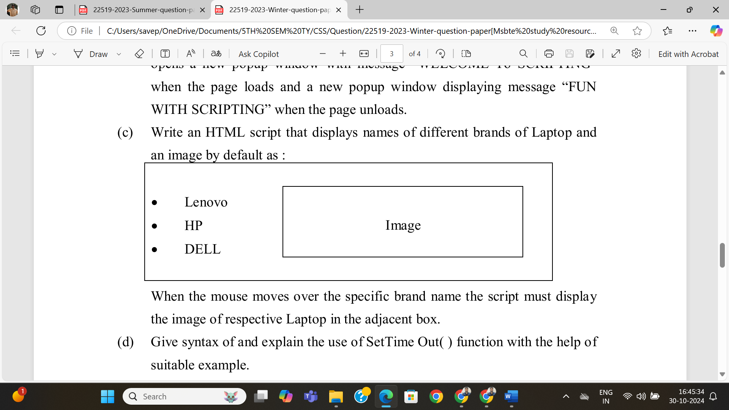



* 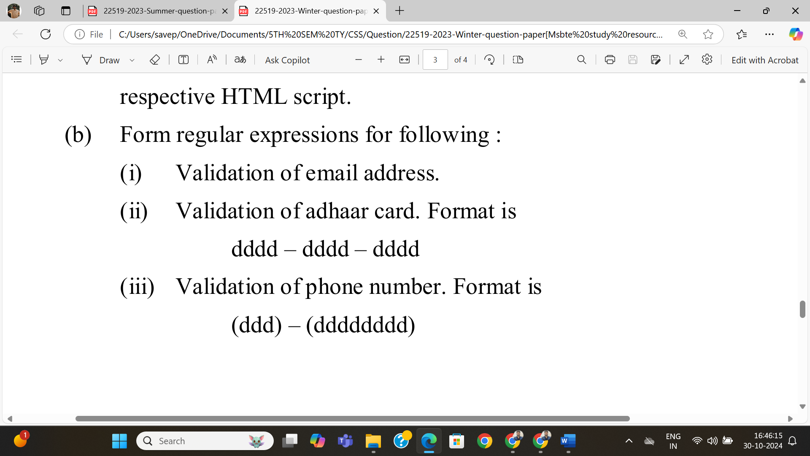



* 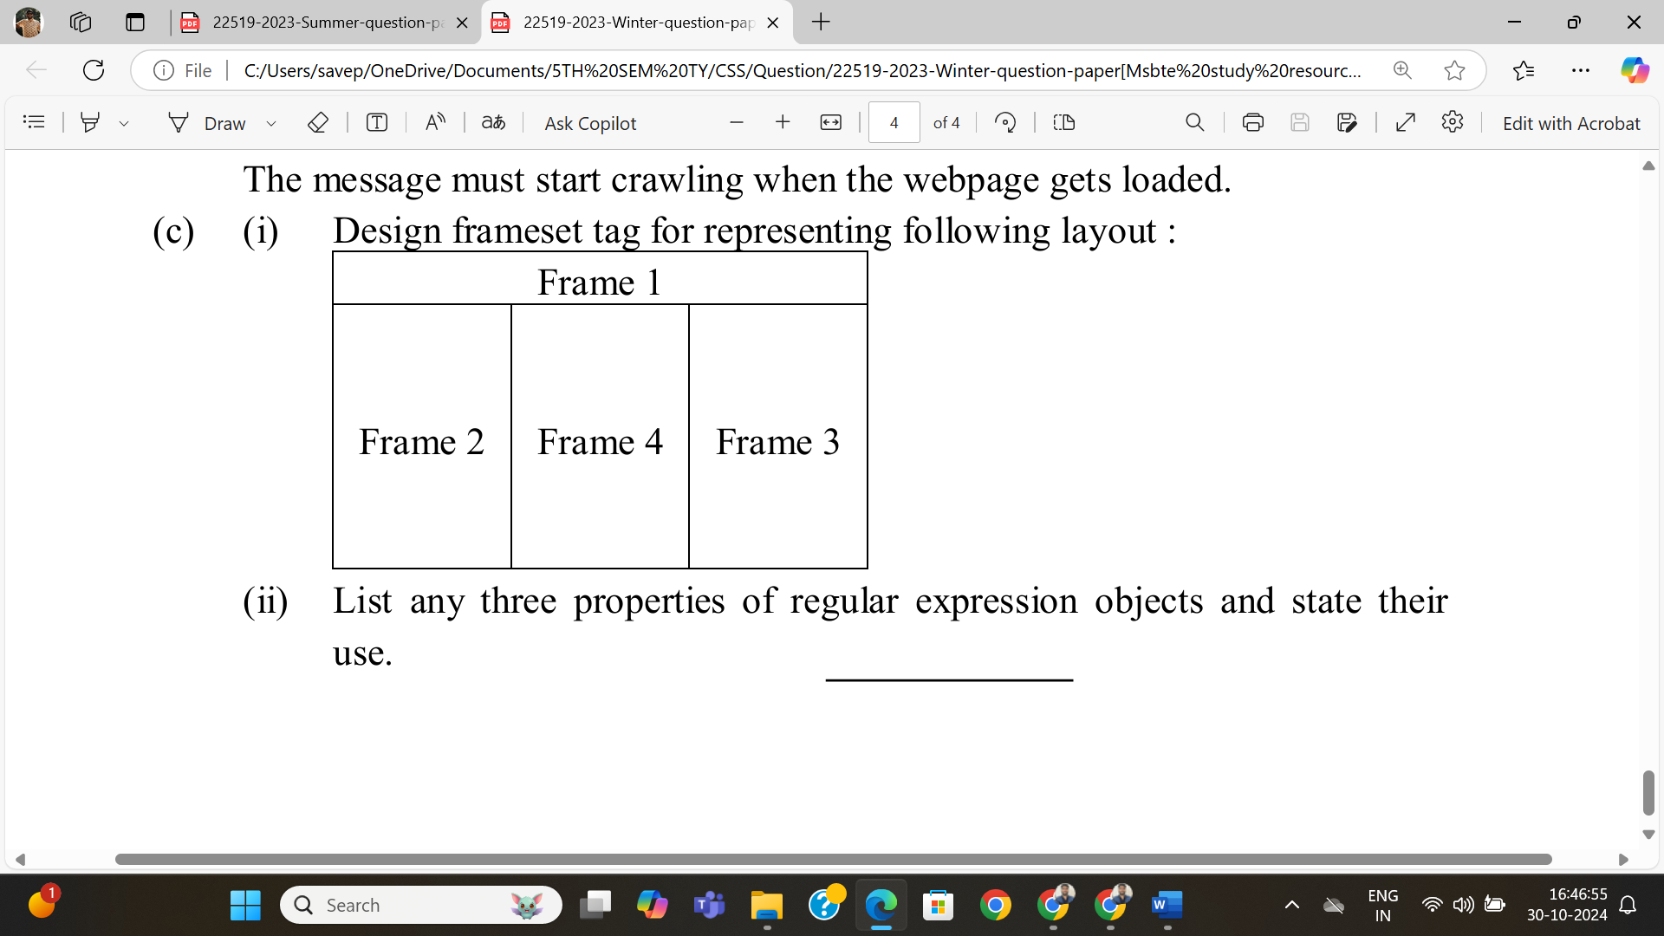



**Summer 2024**

